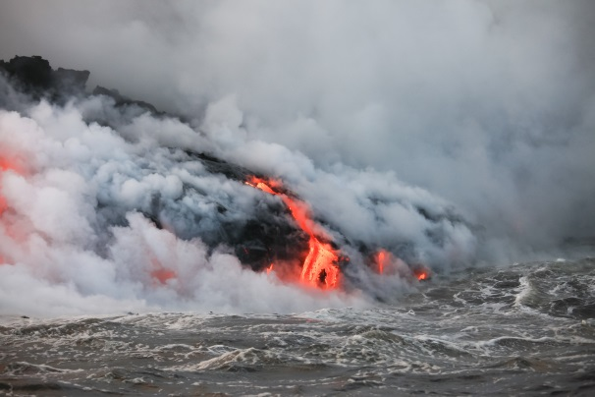Student worksheet

6.4 Tectonic plates can be constructive or destructive

Pages 124–127 and 217

The effects of tectonic plate movement

1 How are underwater earthquakes able to form tsunamis?

2 In what year did an underwater earthquake trigger a massive and highly destructive tsunami in northern Japan?

3 Where was the centre of the Japanese earthquake and what was the result of it?

4 Why is Japan the most seismic country in the world?

5 What happens when a volcano erupts?

6 Why do people live on active volcanoes if they know they will erupt?

7 If Hawaii is in the middle of a tectonic plate, why does it have an active volcano?

8 How does a hotspot develop?

9 Why are the Hawaiian Islands spread into a chain?

10 Draw a diagram to illustrate the Hawaiian volcano, the plate movement and the pattern of islands that results.

|  |
| --- |
|  |

11 How can there be an earthquake in the middle of a tectonic plate?

12 In which direction is Australia’s Indo-Australian plate moving?

Extend your understanding

A hotspot is not the only place where a volcano can form. Volcanoes can also be formed on convergent boundaries. Conduct some research about convergent boundaries and answer the following questions.

13 Which types of plates must collide in order to form a convergent volcano (continental, oceanic or both)?

14 Explain how the collision of two plates can result in a volcano.

15 Geographically, where are these volcanoes usually located?

16 In the space below, illustrate the formation of a volcano from a convergent boundary.

|  |
| --- |
|  |